Install Python to Linux

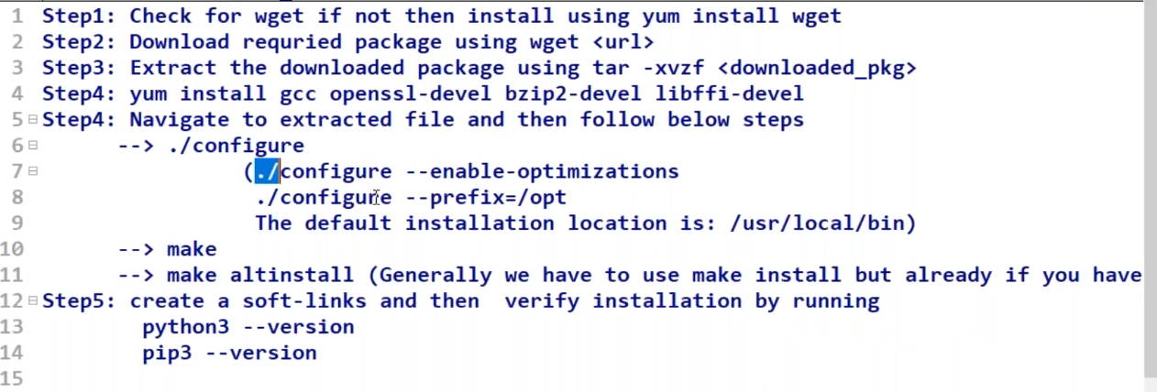

vim /etc/hostname

2 exit

3 ls

4 exit

5 wget --version

6 yum install wget -y

7 cd /opt/

8 wget https://www.python.org/ftp/python/3.10.11/Python-3.10.11.tgz

9 ls ll

10 ls -lrt

11 tar -xvzf python-3.10.11.tgz

12 ls -lrt

13 tar -xvzf Python-3.10.11.tgz

14 rm Python-3.10.11.tgz

15 ls -lrt

16 ls

17 yum install gcc openssl-devel bzip2-devel libffti-devel

18 ls

19 cd Python-3.10.11/

20 ls

21 ./configure

22 make

23 make altinstall

24 ls -lrt /usr/local/bin/

25 cd /usr/local/bin/

26 ./python3.10 --version

27 python --version

28 ln -s python3.10 python3

29 python3 --version

30 ln -s pip3.10 pip3

31 pip3 --version

32 ls

33 cd

34 python --version

35 python3 --version

36 pip --version

37 pip3 --version

38 history